ApexPlanet Software Pvt. Ltd. Cybersecurity & Ethical Hacking INTERNSHIP PROGRAM TASK-2

Name- Shreya Kamath

College- Sophia College for Women(Empowered Autonomous)

Date- 04/05/2026

- Objective
- Learn reconnaissance, scanning, and network traffic analysis.

- Tools Used
- VMware
- Kali Linux
- Metasploitable2
- Nmap
- Wireshark
- Netcat
- OpenVAS (Greenbone Vulnerability Manager)

Step 0: Get Target IP (Very First Step)

On Metasploitable2 Terminal:

ifconfig

Login: msfadmin / msfadmin

Note the IP (e.g., 192.168.56.101)

Screenshot:
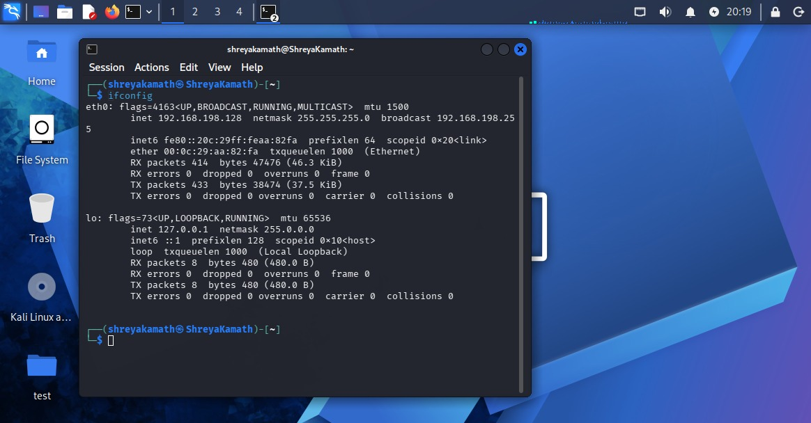
Metasploitable2 IP Address

On Kali Linux Terminal:

ifconfig

Ensure both systems are on the same network (e.g., 192.168.56.x)

Screenshot:
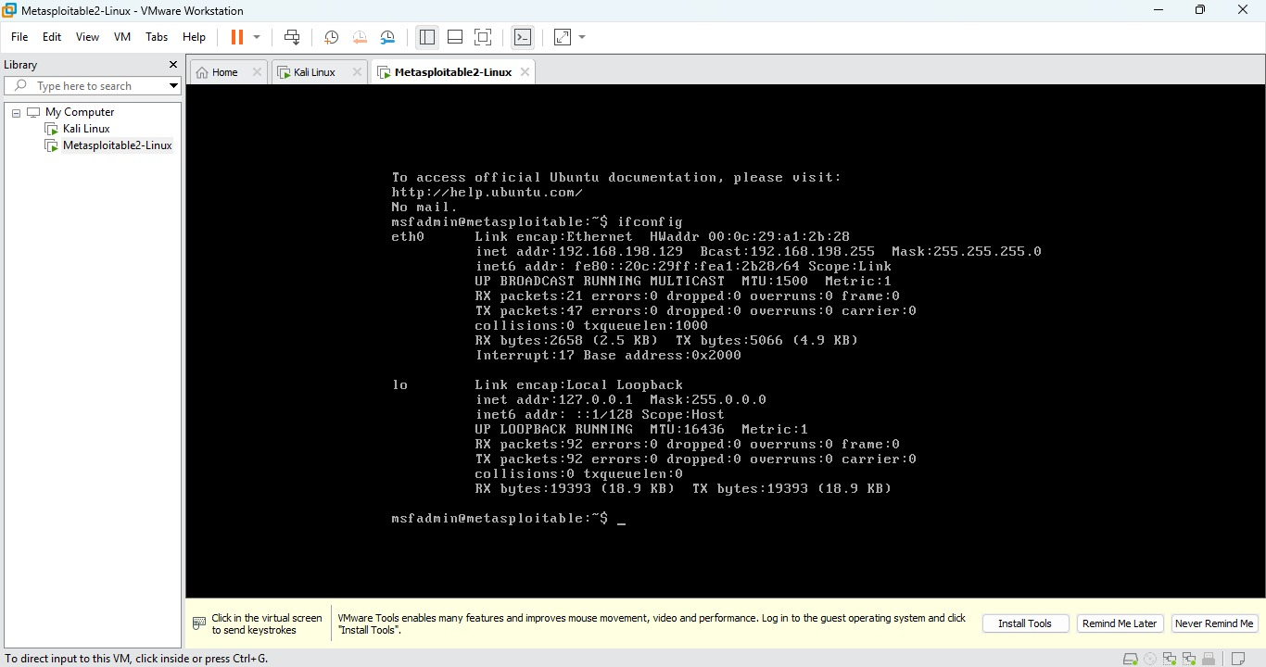
Kali Linux IP Address

Step 1: RECONNAISSANCE

1.1 Passive Reconnaissance

whois google.com
nslookup google.com

Screenshot:
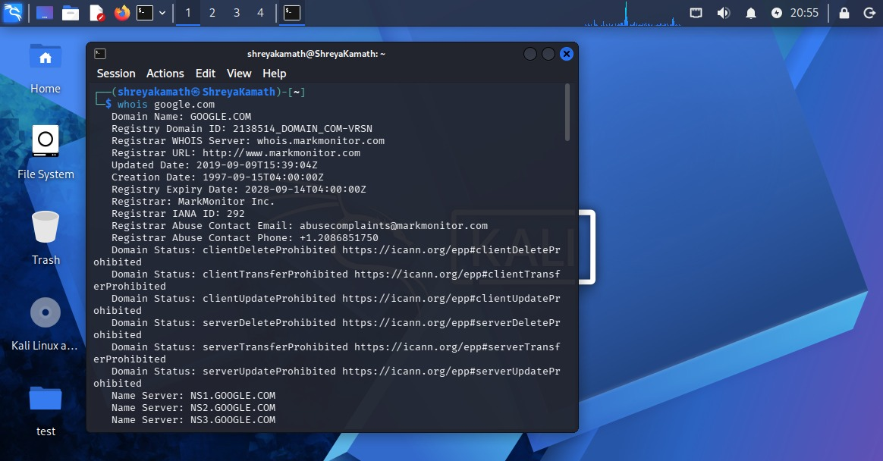

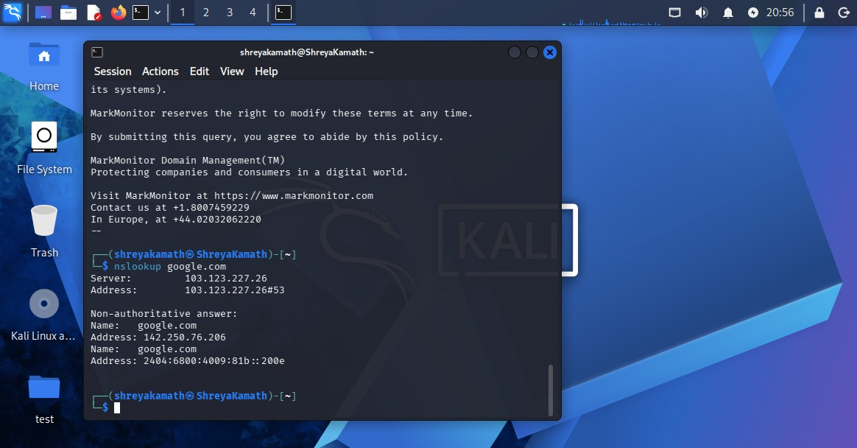
Whois and Nslookup Output

1.2 Active Reconnaissance

Ping Target

ping -c 4 <target-ip>

Screenshot:
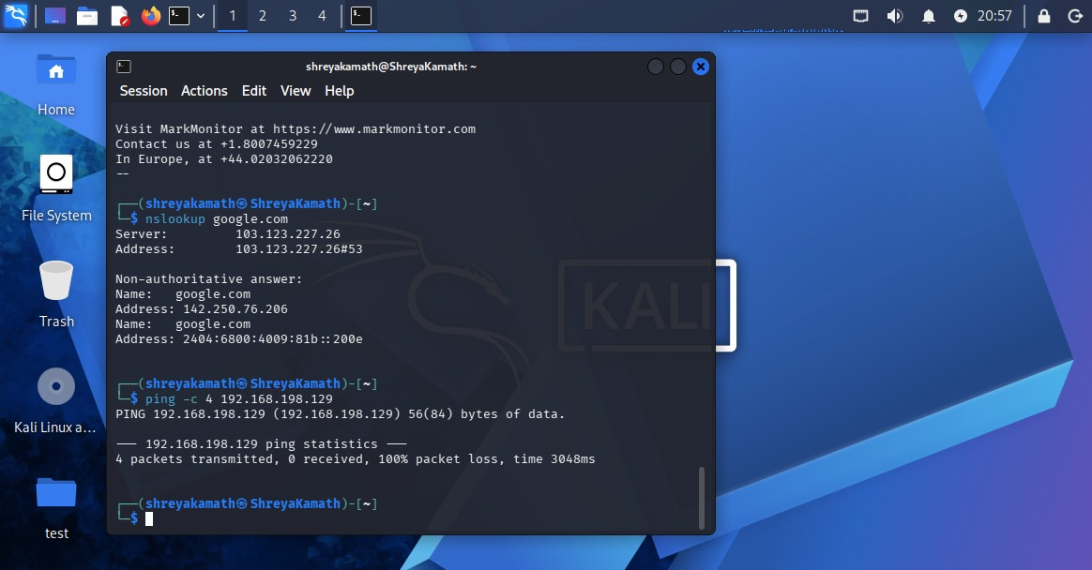
Ping Result

Find Live Hosts

nmap -sn 192.168.56.0/24

Screenshot:
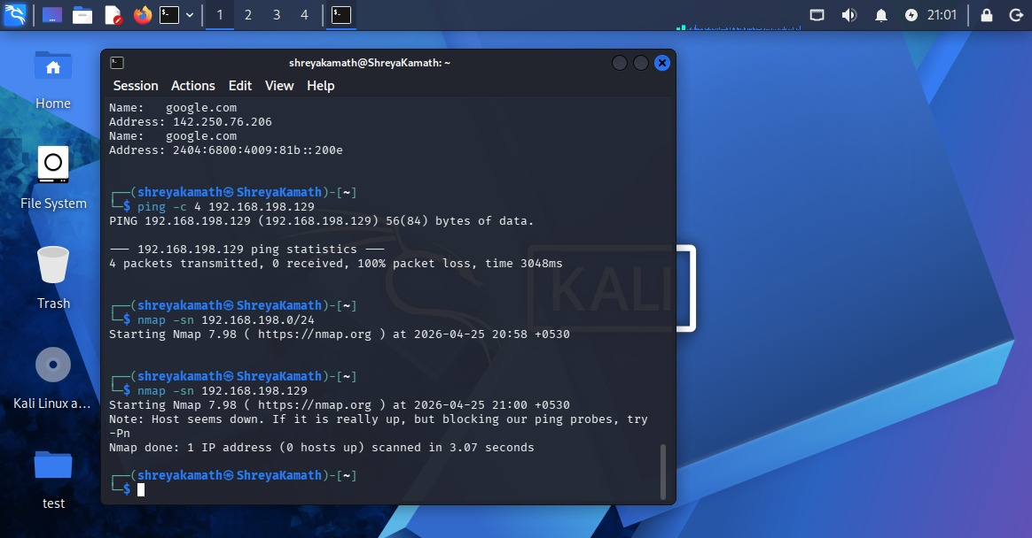
Live Hosts Scan

Banner Grabbing

nc <target-ip> 80

Screenshot:
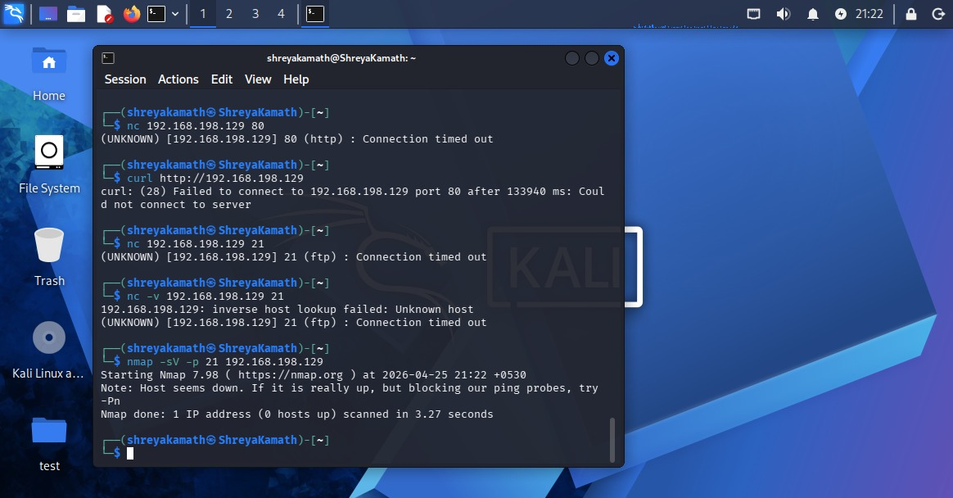
Banner Grabbing Output

Observation:

Target system was successfully identified and network connectivity verified.

Step 2: PORT & SERVICE SCANNING

Basic Scan

nmap <target-ip>

Screenshot:
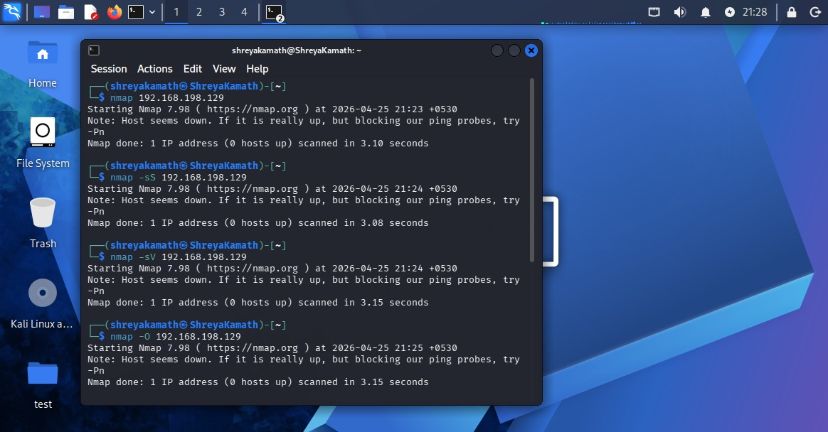
Basic Scan Output

2.1 Nmap TCP & UDP Scans

nmap -sS <target-ip>
nmap -sU <target-ip>

Screenshot:

TCP and UDP Scan Results

2.2 Service Version Detection

nmap -sV <target-ip>

Screenshot:

Service Version Output

2.3 OS Detection

nmap -O <target-ip>

Screenshot:
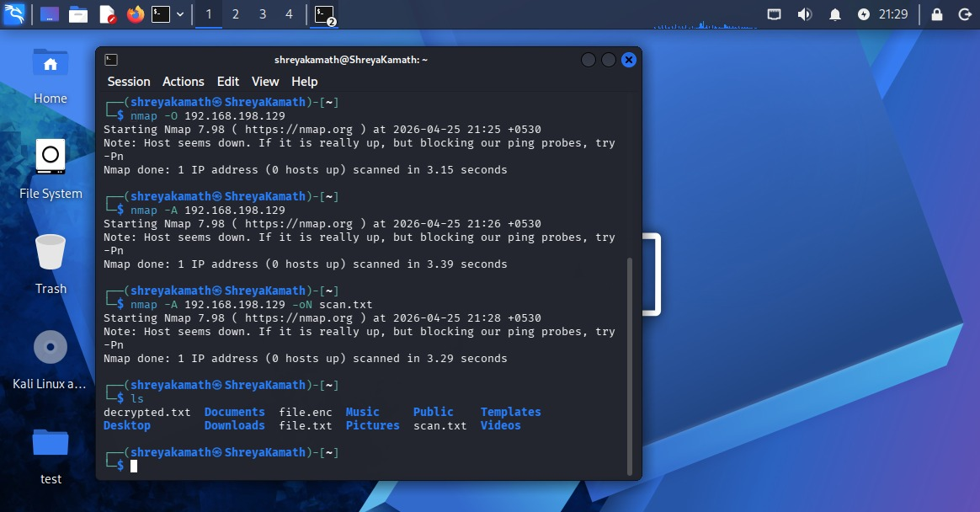
OS Detection Output

2.4 Create Scan Report

nmap -A <target-ip> -oN scan.txt
ls

Screenshot:

Saved scan.txt file

Observation:

Open ports, services, and OS details were successfully identified and documented.

Step 3: VULNERABILITY SCANNING

3.1 Setup OpenVAS

gvm-setup
gvm-start

Screenshot:
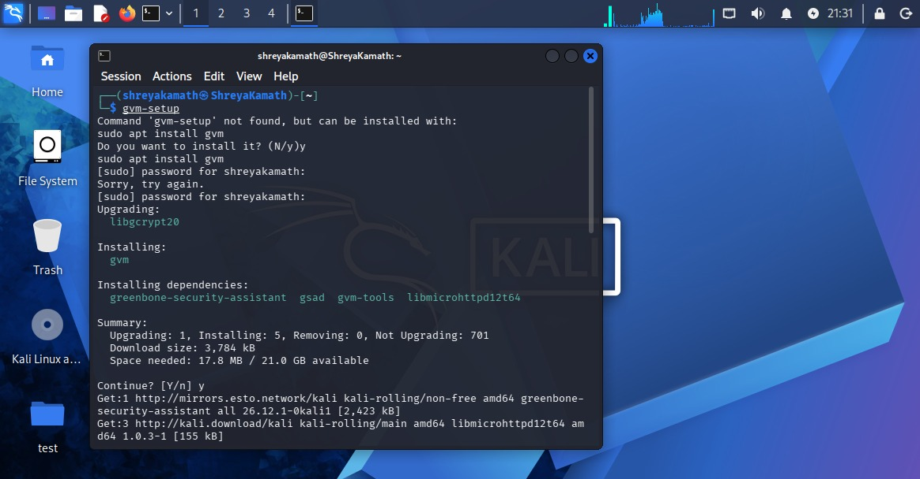

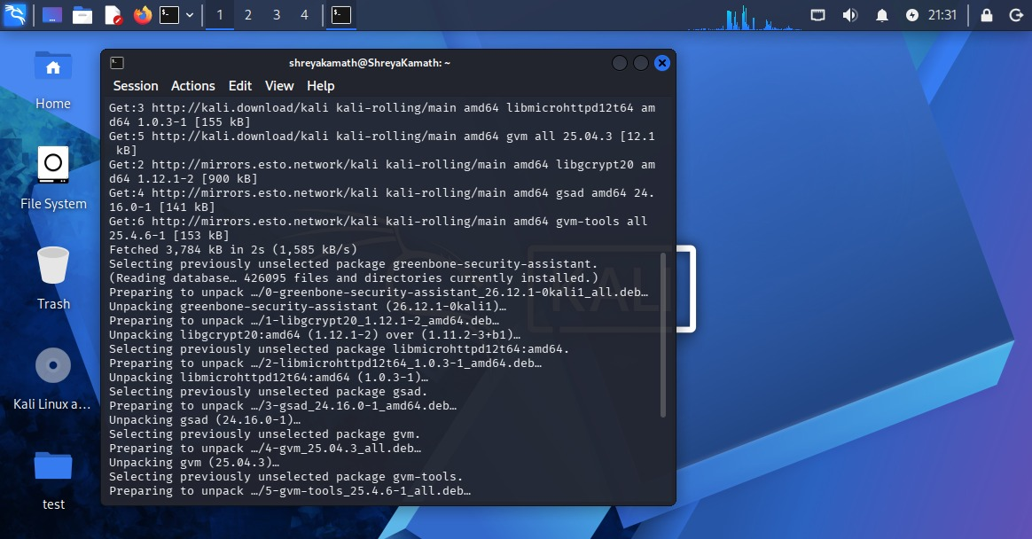
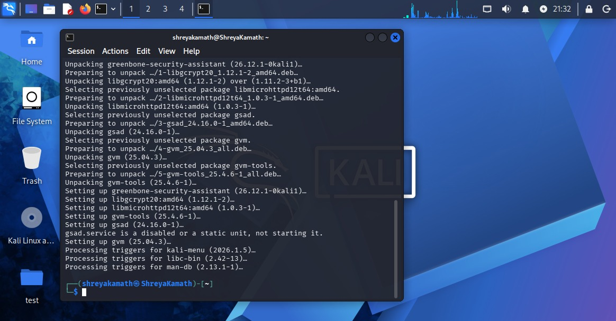

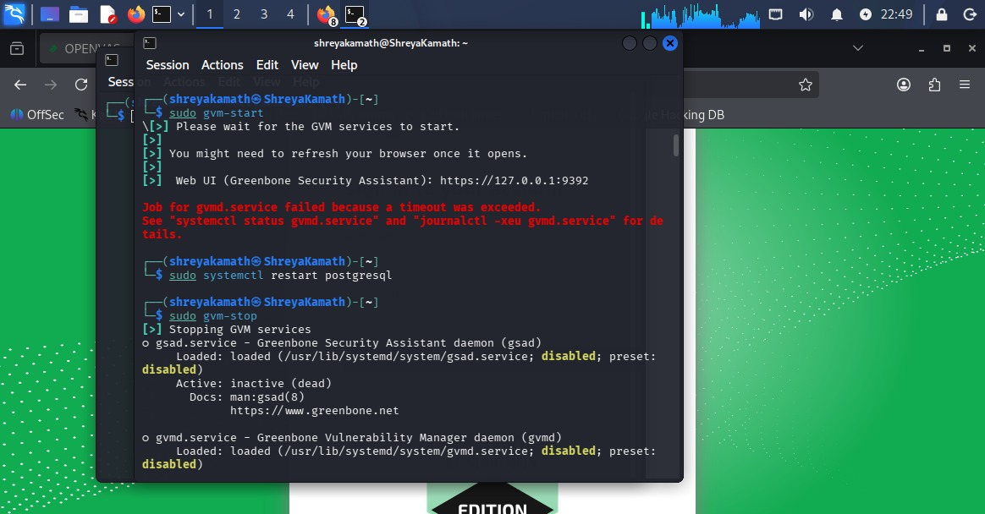

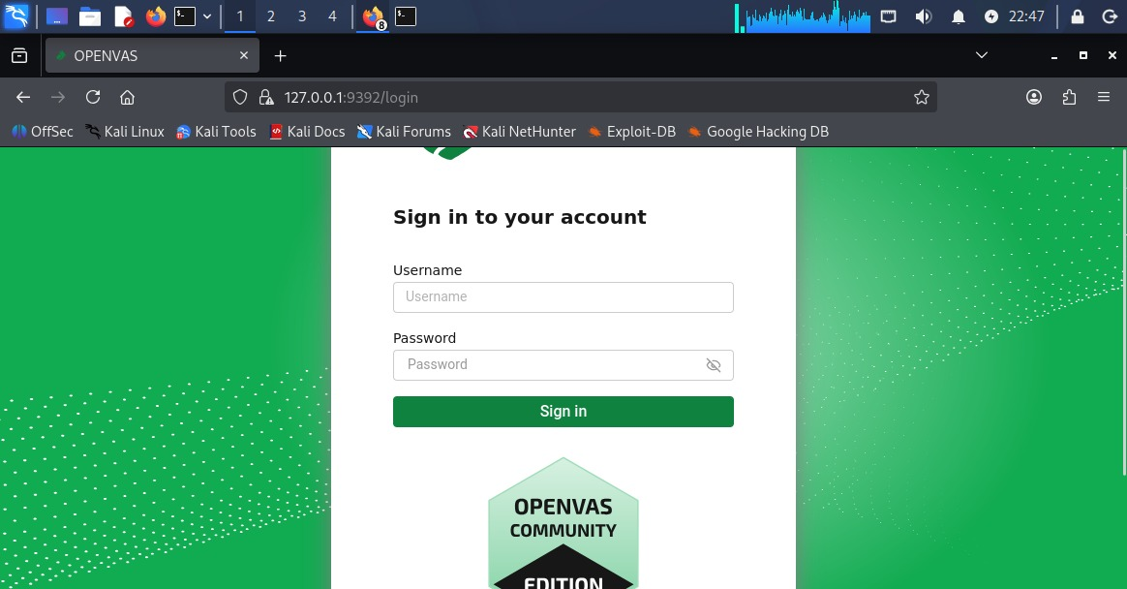

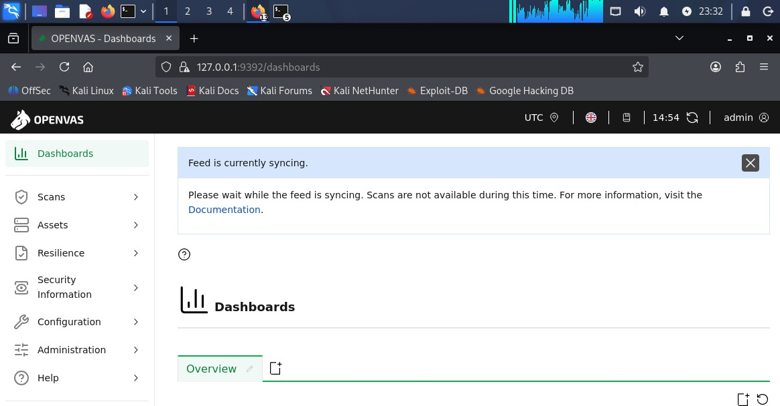
OpenVAS Setup/Start

3.2 Scan Test VM (Metasploitable2)

Open Browser:

https://127.0.0.1:9392

Login using credentials from terminal

Add Target:

Name: metasploitable

IP: <target-ip>

Screenshot:
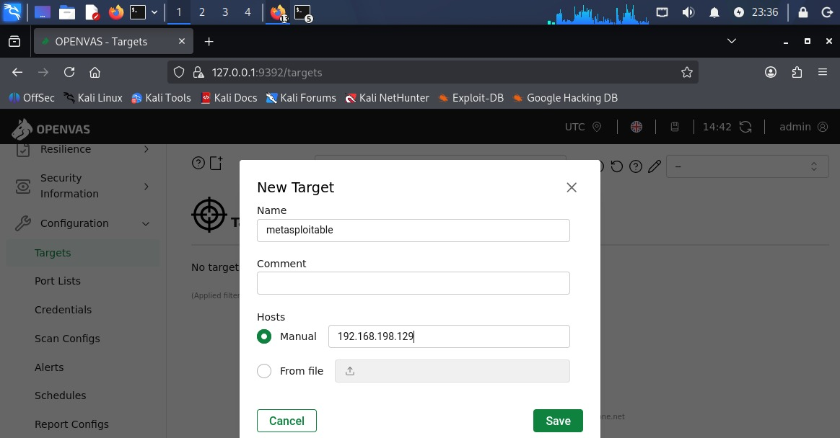

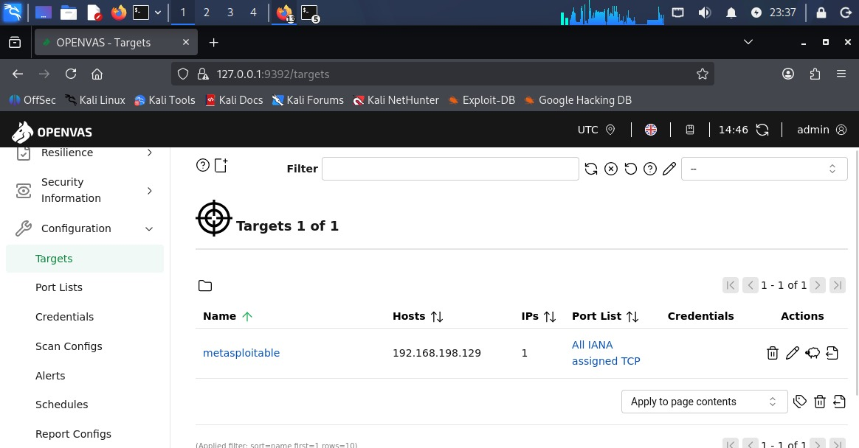
Target Configuration

Start Scan:

Go to Scans → Tasks
Create new task
Start scan

Screenshot:

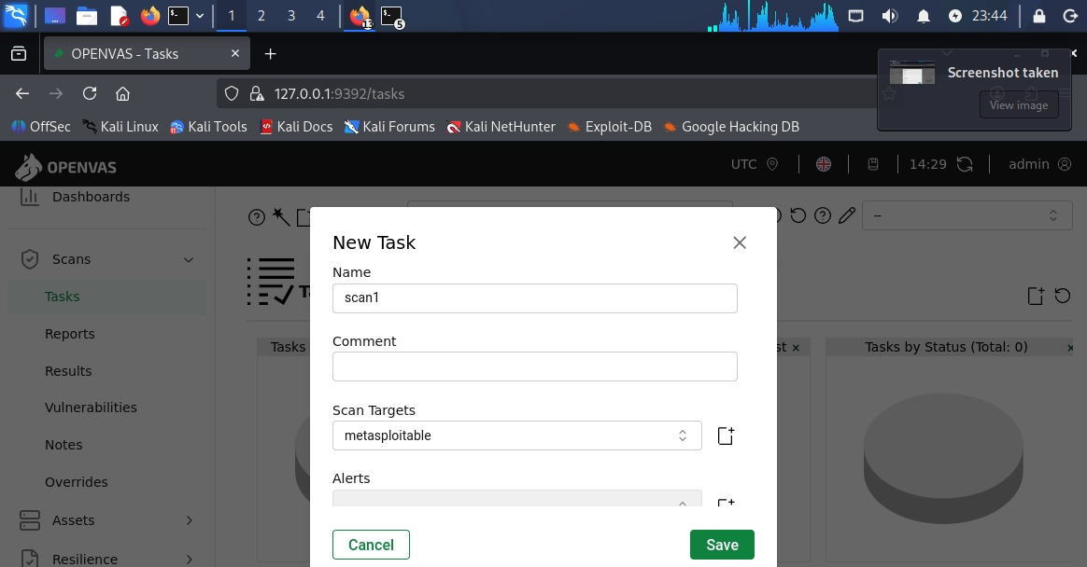

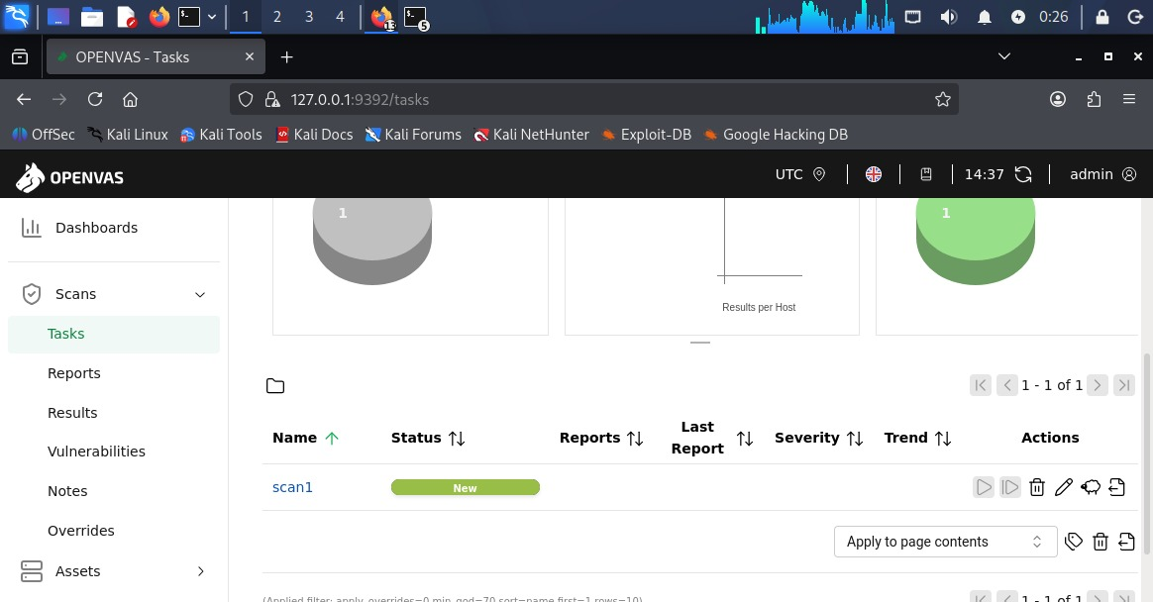
Scan Running

3.3 Analyze Vulnerability Report

Open completed scan report

Analyze vulnerabilities based on:

Critical

High

Medium

Low

Screenshot:

Vulnerability Report

Observation:

Vulnerabilities in the target system were successfully identified and categorized based on severity.

Conclusion

This activity provided practical experience in reconnaissance, port scanning, and vulnerability assessment, which are essential phases in penetration testing and cybersecurity analysis.

Here is your clean Word document format for Section 4 & 5, matching your exact headings and structure (with commands + screenshot placement):

Step 4: Packet Analysis with Wireshark

4.1 Capture HTTP, FTP, DNS Traffic

Steps:

Open Wireshark

Select interface (eth0 / wlan0)

Click Start Capture

Generate Traffic (Kali Terminal):

ping <target-ip>

OR open browser and visit any website

Apply Filters in Wireshark:

http
dns

Screenshot:
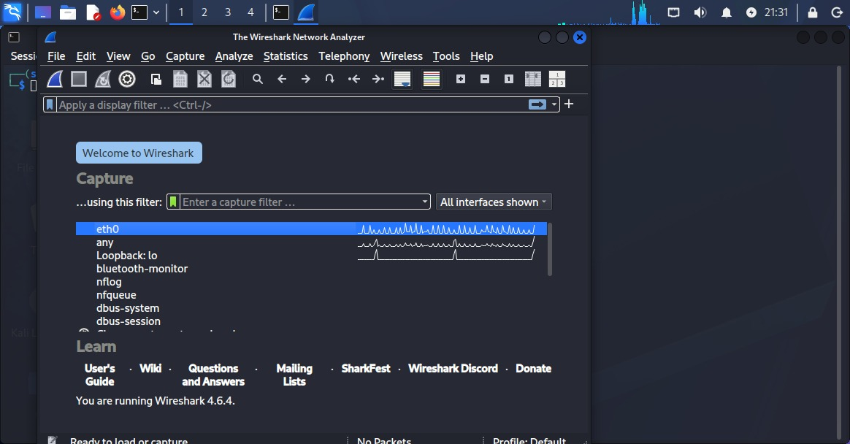

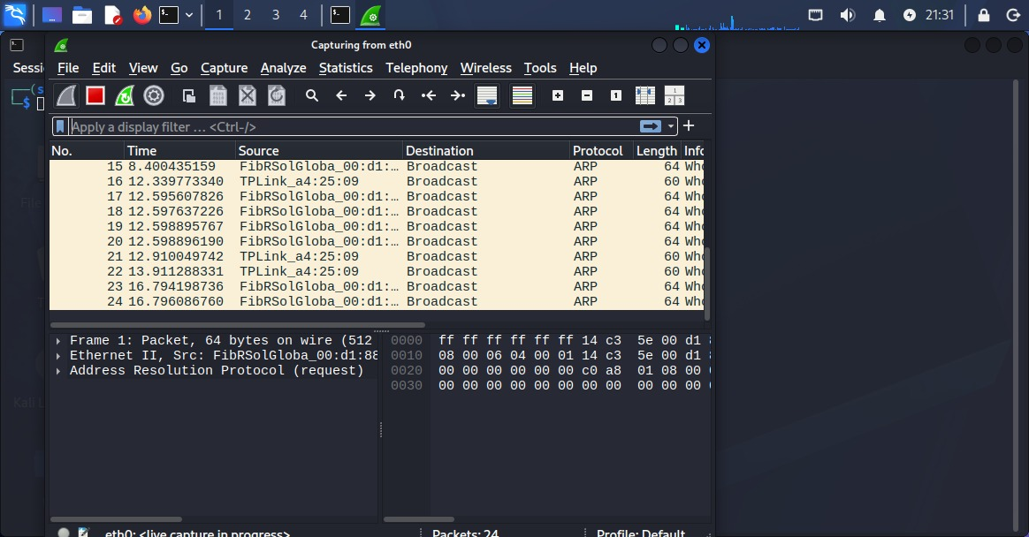
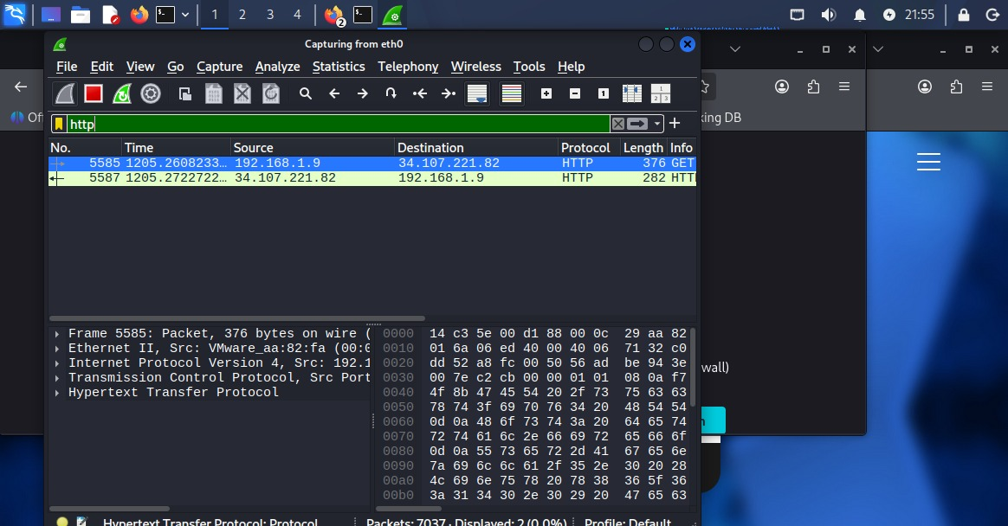

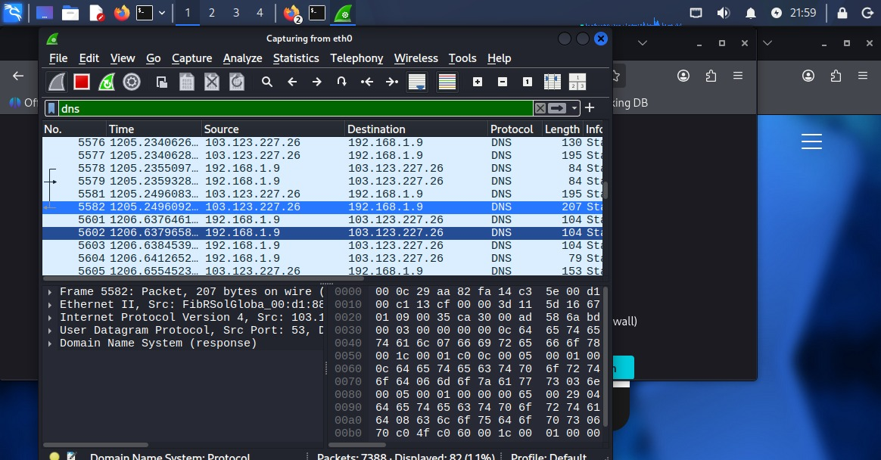
HTTP & DNS Traffic Captured

4.2 Filter Credentials from Unencrypted FTP Traffic

Run in Kali Terminal:

ftp <target-ip>

Login:

Username: msfadmin

Password: msfadmin

Apply Wireshark Filter:

ftp.request.command == "USER" || ftp.request.command == "PASS"

Screenshot:
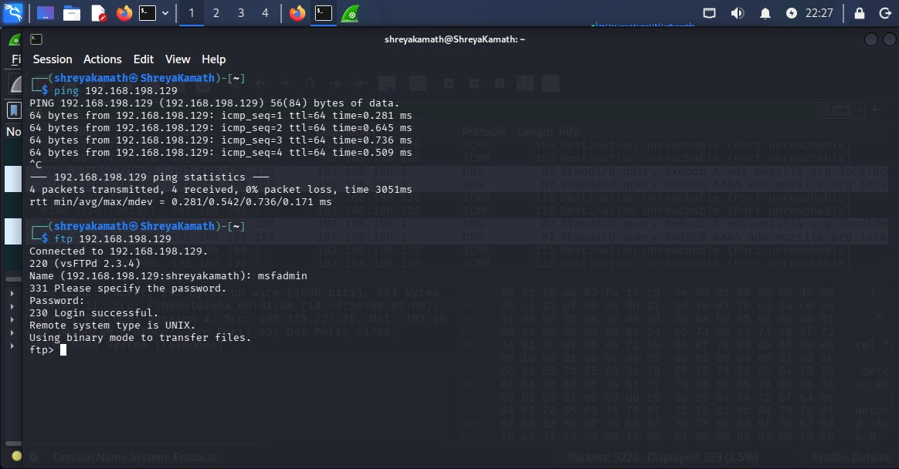

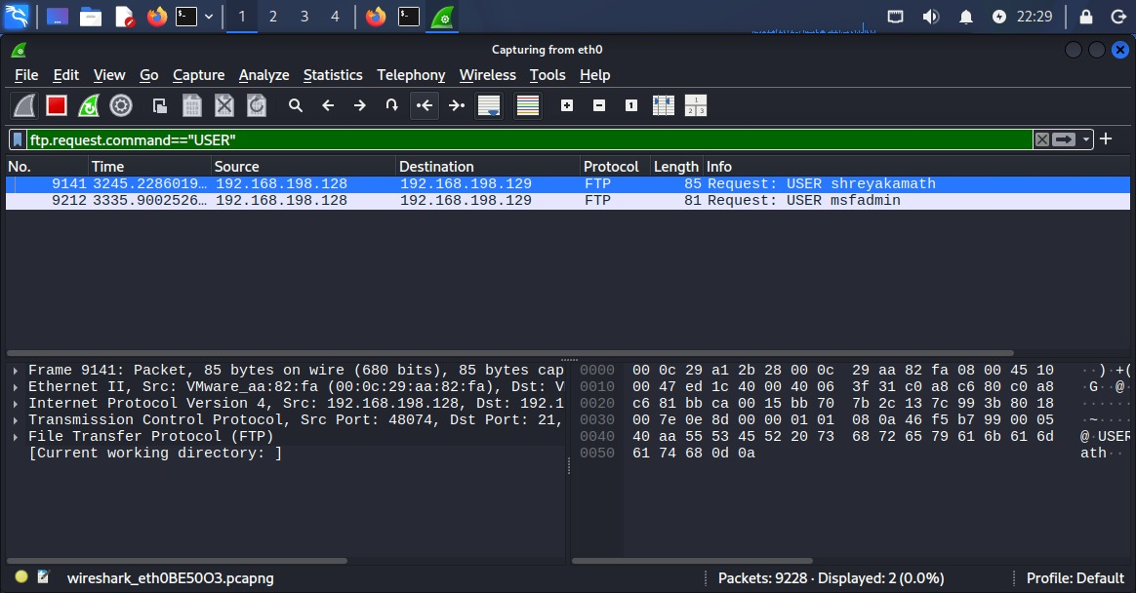
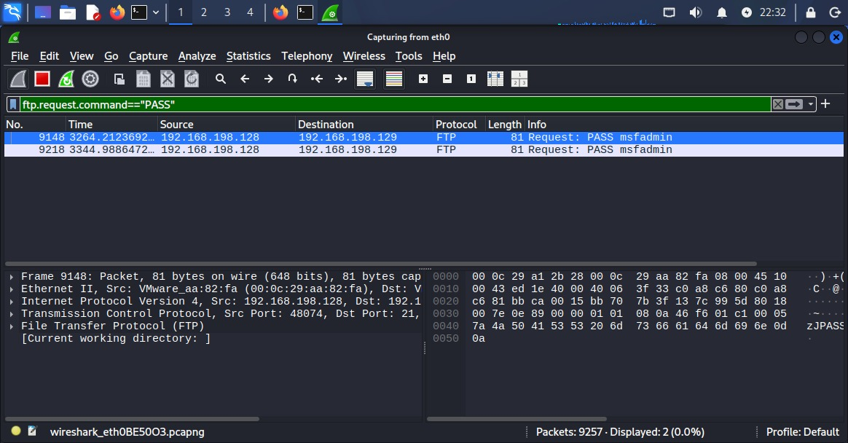
FTP Credentials Visible

4.3 Analyze SYN Flood Attack (hping3)

Run in Kali Terminal:

hping3 -S --flood -p 80 <target-ip>

Apply Wireshark Filter:

tcp.flags.syn == 1

Screenshot:
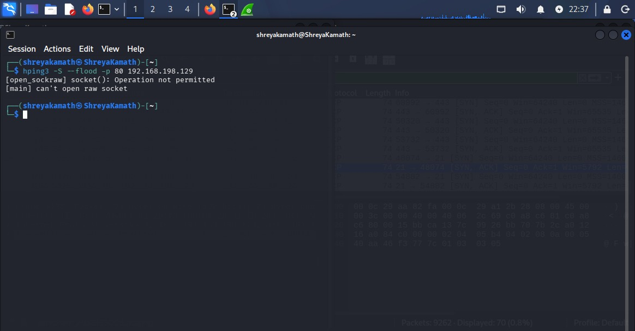

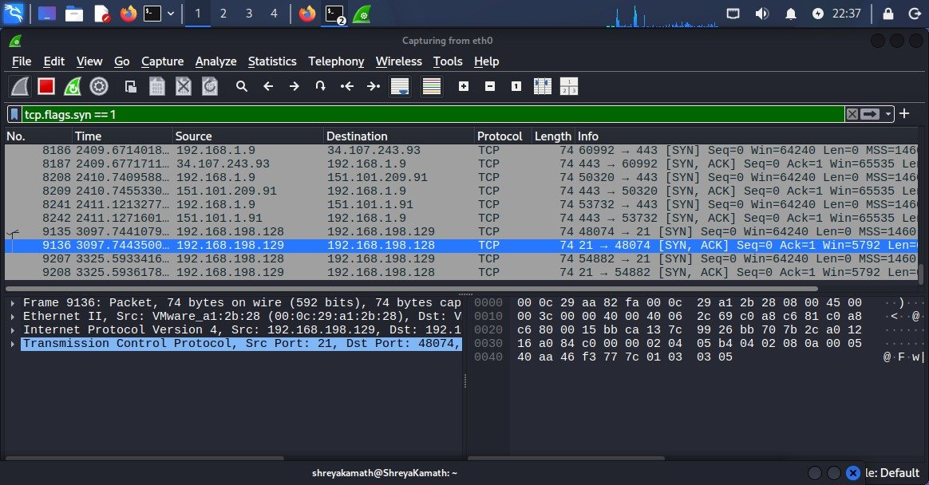
SYN Flood Traffic

Observation:

Captured packets showed HTTP, DNS, and FTP traffic. FTP credentials were visible due to lack of encryption. SYN flood attack generated multiple SYN packets indicating potential DoS activity.

Step 5: Firewall Basics

5.1 Create Simple iptables Rules

Block Port 80:

sudo iptables -A INPUT -p tcp --dport 80 -j DROP

Allow Port 22:

sudo iptables -A INPUT -p tcp --dport 22 -j ACCEPT

Screenshot:
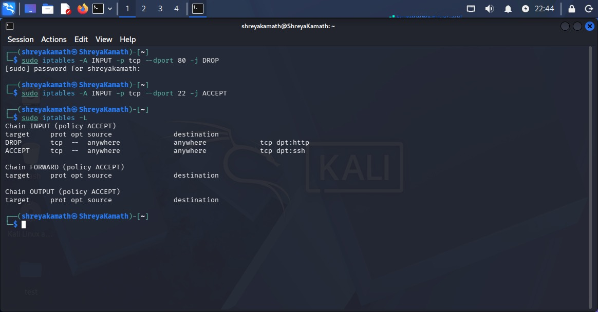
Port 80 Blocked Port 22 Allowed

5.2 Demonstrate Blocking a Port Scan Attempt

Check Firewall Rules:

sudo iptables -L

Screenshot:

iptables Rules List

Observation:

Firewall rules successfully restricted access to specific ports and demonstrated protection against unauthorized scanning attempts.

Conclusion

This task demonstrated packet analysis using Wireshark and implementation of firewall rules using iptables, helping in understanding network monitoring and system security.

